|  |  |
| --- | --- |
|  | Student Name _______________________    **Eastern Goldfields College**  Year 11 Mathematics Essential U1 2019  Task 5 Test 3 – Calculator Assumed1 |

**Time allowed: 60 minutes Task Weighting: 9%** Total Marks $\frac{}{55}$

**One A4 page of notes permitted in this section.**

**Question 1** [3 Marks – 1,2]

Calculate the perimeter of the following shapes

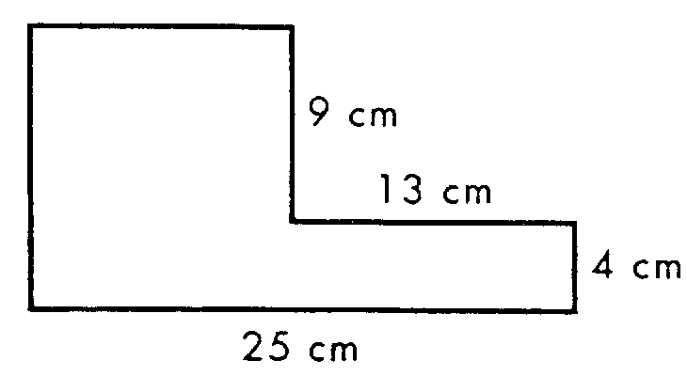

1. 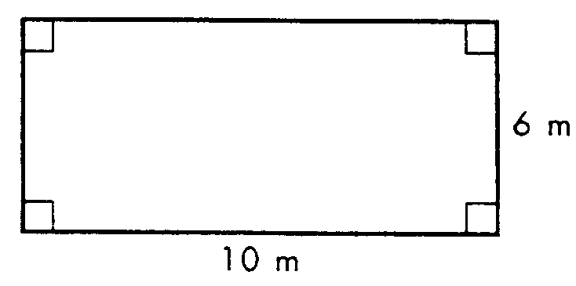 b)

**Question 2** [1 Mark]

Farmer Jack wants to put a 1m high fence around the paddock for his sheep. If the area of the paddock is 24m2 what could be the dimensions of the paddock?

**Question 3** [3 Marks]

For a warm-up, Edmond runs one lap of his soccer pitch which is 120m long and 100m wide. Cody complains that his coach makes him run 4 laps of the basketball court, which is 30m long and 15m wide, when they train. Who runs further in their warm-up?

**Question 4** [2 Marks]

Isobel wants to place skirting board around the floor in her bedroom and has 35m of skirting board leftover from another room. If her room is 8m long and 7.5m wide, will she need to buy any more skirting board and if so, how much?

**Question 5** [8 Marks]

Complete the missing values to make the conversions true

|  |  |  |  |  |  |  |  |
| --- | --- | --- | --- | --- | --- | --- | --- |
| **a** | 20.68 cm2 |  | m2 | **e** | 1.2 m2 |  | mm2 |
| **b** | 6.23 kilograms = |  | grams | **f** | 5400 joules = |  | kilojoules |
| **c** | 40 cm3 = |  | mm3 | **g** | 96 kJ = |  | calories |
| **d** | 70000 cm3 = |  | m3 | **h** | 0.812 kW = |  | Watts |

**Question 6** [2 mark]

Ali has a jewellery box that is 50cm long and 30 cm wide. If the height of the box is 25cm, what is the volume of the box in cm³?

**Question 7** [2 mark]

A water tank is constructed in the shape of a cylinder. If the base of the water tank has an area of 25m² and stands 6m tall, calculate the amount of water that can fit in the tank. Give your answer in kL.

**Question 8** [6 marks – 2, 4]

A supply plane contains crates which hold smaller packages in place. The large crate is a cube of side length 2.5m.

1. Calculate the volume inside the crate
2. On an upcoming mission the plane needs to deliver food packages to a small village. If each food package is a rectangular box 10cm wide, 25 cm long and 5cm high, how many smaller packages can fit into each large crate?

**Question 9** [6 marks – 1, 1, 2, 2]

You are building a drag car with one of your friends. The fuel tank you choose to use has the dimensions of 670mm by 605mm by 210mm.

1. Draw the tank and label the dimensions.
2. Calculate the volume of the tank you have drawn.

(c) Find the capacity of the tank to the nearest litre.

(d) The actual capacity of fuel tanks can vary by as much as 3%. This means the tank has the ability to hold 3% more or less than its stated capacity. Using your answer from part (c), calculate the maximum and the minimum capacity of the tank when there is a 3% variation.

**Question 10** [8 marks]

Complete the following table

|  |  |  |
| --- | --- | --- |
| Joule (J) | Kilojoule (kJ) | Calories |
| 2000 |  |  |
|  |  | 3 |
|  | 5160 |  |
| 89200 |  |  |

**Question 11** [3 marks]

An electrician has installed a power point that can only power appliances that use less than 0.1 kilowatts of power per hour (kW/h). Justify with a mathematical calculation whether the following appliances would be able to use this power point.

1. Lightbulb that uses 60 watts per hour (W/h)
2. Microwave oven that uses 1500 W/h
3. 34cm colour TV that uses 55 W/h

**Question 12** [5 marks – 2, 2, 1]

The formulae for Basic Metabolic Rate are below, giving the result in calories. The weight is measured in kilograms and the height measured in centimetres.

**Female BMR (in calories) = 655 + (9.6 x weight) + (1.8 x height) – (4.7 x age)**

**Male BMR (in calories) = 66 + (13.7 x weight) + (5 x height) – (6.8 x age)**

Calculate the BMR (in kilojoules) for the following people, showing all your working.

a) A 17 year old male, 1.72m tall, weighing 58kg.

b) A 54 year old male, 178cm tall, weighing 73kg.

c) What happens to BMR as people get older? Explain what aspect of the formula causes this.

**Question 13** [6 marks – 1, 2, 3]

Anne has a clothes dryer that is rated at 2350 watts and is used for about half an hour each morning during summer.

a) Convert 2350 watts to kilowatts

b) What is the total number of kilowatt hours used by the dryer in one week.

Anne is concerned about her electricity usage (consumption) during the winter. She decides to compare her electricity bill to her neighbour Bob, who has the exact same model of dryer. Both use their dryers for **1.5 hours** each day during winter. Anne puts hers on at **10 am** whilst Bob turns his on at **5pm**.

**On-Peak Electricity Time = 2pm – 7pm charged at 49.3 cents per kWh.**

**Off-Peak Electricity Time = 9am – 12pm charged at 13.6 cents per kWh.**

c) Use the information above and below to determine who is charged the least per week and whether or not Anne should be concerned about her electricity usage.

Explain your answer with the support of a mathematical calculation.

**END OF TEST**